CSE 278 Lab 1

Tasks overview:

In this lab, we need to get familiar with Linux and C++ development & execution environment. Learn how to use the most popular tools used for most of the software engineers.

1. Install the Linux and get familiar with the command
2. Set up the Github repository and learn how to download/upload using git command
3. Start the basic C++ programming practice (var&io)

Linux Installation:

In this lab, let’s first get familiar with Linux which you will use during this semester. It is so powerful and it’s very likely that you will need to use it in the future as well. In this class, we have two options for the Linux, the virtual machine and the remote server. In the lab, you are required to know how to use both.

# Virtual machine:

Virtual Box is a very popular virtual machine software, which creates the virtual hardware to run any operating system (i.e., Mac, Linux and Windows). So you can install a Virtual box in your own computer and then install the Linux to the Virtual machine provided by the Virtualbox software.

The download link for VirtualBox can be found below:

<https://www.virtualbox.org/wiki/Downloads>

Based on your computer, please choose the correct version (i.e., OS X, Linux and Windows).

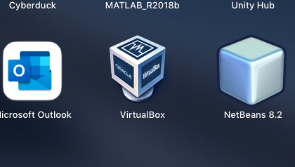

## Two option A: install the new OS:

Please get the operating system ISO file (ubuntu-20.04.3-desktop-amd64.iso) by clicking the following link or search “Ubuntu 20 download”.

<https://ubuntu.com/download/desktop>

or from

<https://drive.google.com/file/d/1c3opAkyuVkd3Sg1NGmku7z09yMVQIn6r/view?usp=sharing>

While downloading the OS, you can create a new machine in the VirtualBox. BTW, you can create as many virtual machines as you want.



Click “New” to create a new machine.

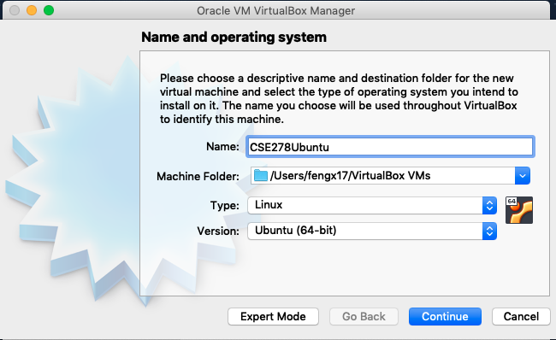

Name the machine based on your preference. Make sure the “Type” is “Linux”. Note: if you use any term that is related to Linux in your project name, it can automatically set the type as Linux.

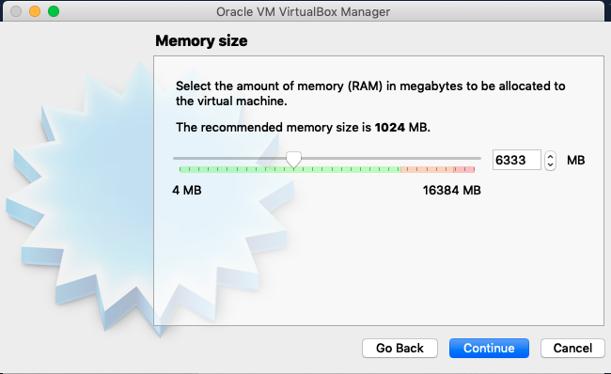

Set the memory size based on your computer.

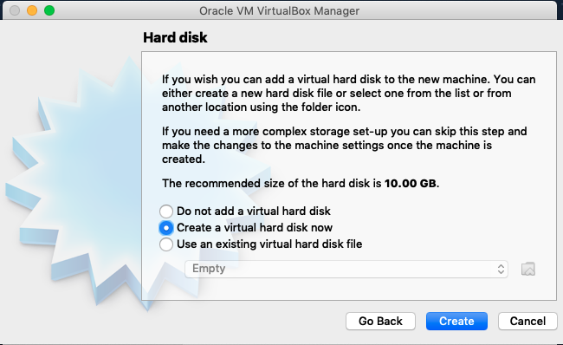

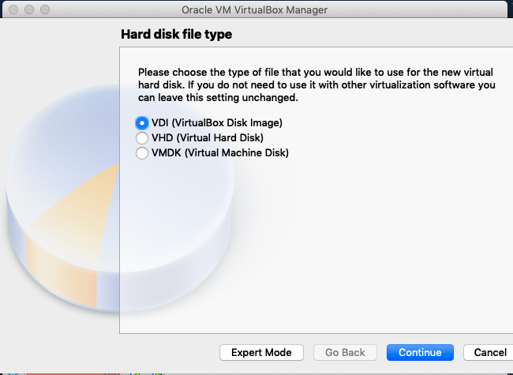

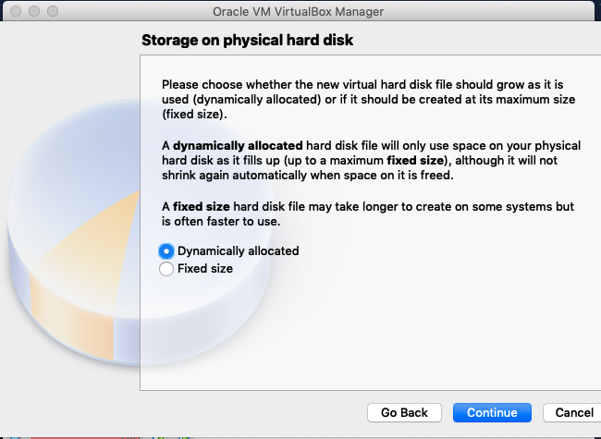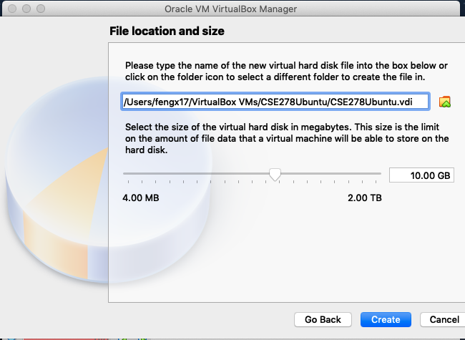

Follow the settings and click create.

In the end, load your “ISO” file to your virtual machine’s storage in the configuration panel and click “start”. You should be able to install the OS now.

## Two option B: Import the OS (recommended):

Please try this one because this virtual machine disc contains the necessary libraries we will use. You can get this following the link:

<https://drive.google.com/file/d/1hLxaaas2xTwldVEBLGU9NT9gWKYDebB3/view?usp=sharing>



This time, go to the “Tools” and click the “import”

Then, click the following to load the file.

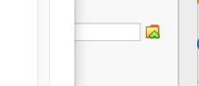

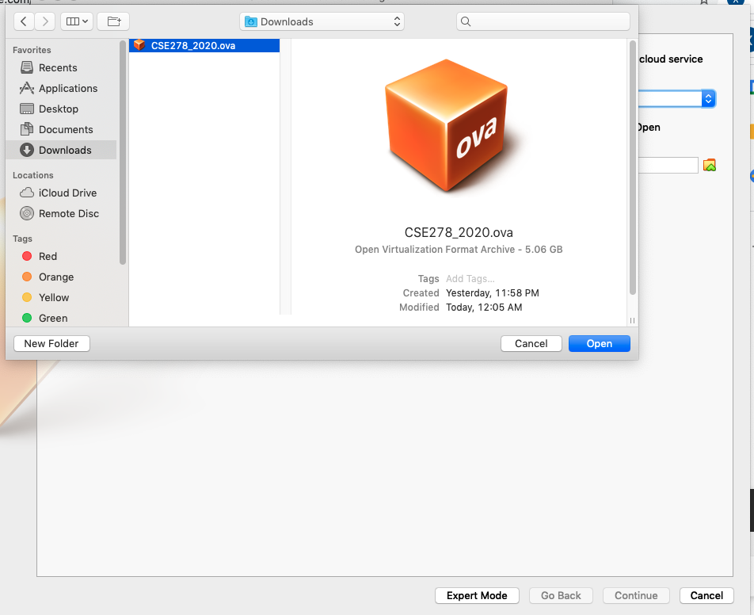

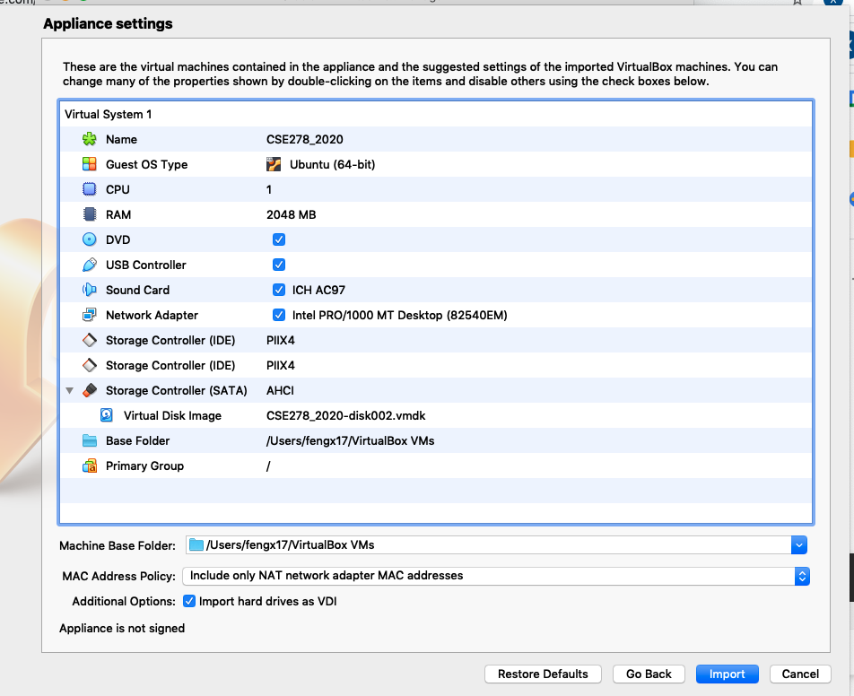

Click import.

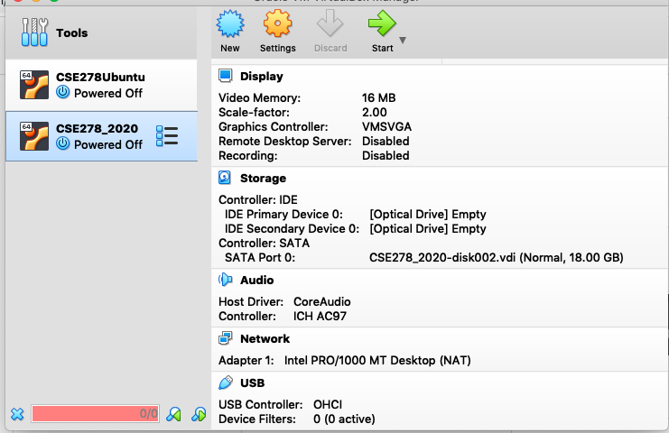

Click “start”.

# Virtual machine:

# Cloud server (Linux & SSH):

What if your machine (physical or virtual) can not run????? As long as you are connected to the internet, you can run Linux on the cloud server. Here we would like to use the Linux server provided by our college!

Open the terminal. (Windows user please install the Powershell). Type:

$ ssh YourID@ceclnx01.cec.miamiOH.edu

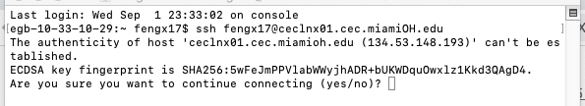

Type yes

Type your password.

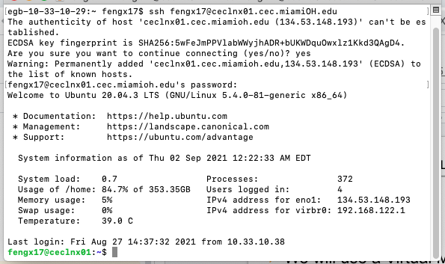

Before you start the lab, please answer the question:

A) How to work on multiple machines with different people.

------Github

1 Create the Github account! (github)

2 Create a repo (a new project in the website). (github)

3 Create the SSH key in your local file (in the terminal of your local computer)

**ssh-keygen -t rsa -C "YourEmail"**

check if you have the key:

ls -al ~/.ssh

# Lists the files in your .ssh directory, if they exist

The public key we use has a name end with “.pub”

Get the key by:

cat ~/.ssh/xxxx.pub

copy the key (starting with ssh-rsa ending with your email)

4 Store your Key to the Github account.

In the Github website, go to “setting” and click “SSH and GPG keys”.

click the “new” to add your key. Give it a title to help you manage all the keys.

5. Download your repo to your linux.

In the github website, open your repo.

Click the “code” (green bottom) and choos “SSH”.

Copy the link provided under “SSH”

Go back to your local machine and open the terminal.

Download the the repo to your local machine by using the following command:

git clone #############(your link)

6. edit the file and update your repo in github.

git add .

git commit -m “YOUR NOTE”

git push -u

next time before you edit your local file, please make sure you update your local file by using the command:

git pull

B) how to edit the source file in the terminal.

----vi “filename” (if not exist, it will create one)

press ‘a’ to edit

press “esc” to quit then type:

“:wq”. : quit and save

“:w”. : quit without save

CODING With C++!

This coding work should be done using the cloud server. Just in case not all of you could finish installing the virtual machine. Please editing the file using the “vi” editor.

1. Please learn the last part “standard IO” in the lecture slides “Week2_C++Basic.pptx”by yourself and type the demos to try the “cin/cout”.

Compile and run

1. Write a programm to show the following string s:

s=”This is a demo to show the special function of slash. \n with the slash now you can see.”

You first try to output the original “s”. Then, replace the “\n” with the following option:

1. \0
2. \062
3. \t
4. \v
5. \r
6. \\
7. \40
8. \12
9. \f
10. \b

Please try the above 10 options and see what happens in the output.